# Microservices Advanced

Kunal Verma

3149552

[Kunal.verma@nagarro.com](mailto:Kunal.verma@nagarro.com)

# Prerequisite

# Please go through the image and video in folder.

# NOTE: IMAGE ,DIAGRM ,VIDEO YML are provided in the folder Please refer them .

# Deliverables

1. Source code GitHub
   * <https://github.com/kunalverma94/MicroserviceJagger>
2. Docker hub image links
   * <https://hub.docker.com/repository/docker/kunal94vverma/orderjag>
   * <https://hub.docker.com/repository/docker/kunal94vverma/userjag>
   * <https://hub.docker.com/repository/docker/kunal94vverma/orderdetailjag>
3. YAML files
   * Please find the YAML for Deployment, Networking, Runtime and Config Map

for following in the “deployment YAML” folder .

1. Screenshots

* Please find the image screenshots and working video in the “Image and Video” folder .

1. Additional

* Docker Compose Support provide
  + Run Locally by start.bat/ps1
  + order
    - <http://localhost:1111/order/1>
  + user
    - <http://localhost:2222/user/1>
  + orderdetail
    - <http://localhost:3333/orderdetail/1>
  + Jagger
    - <http://localhost:16686/>
  + MySQL
    - Port: 3306
    - User: root
    - Password: password

# Working

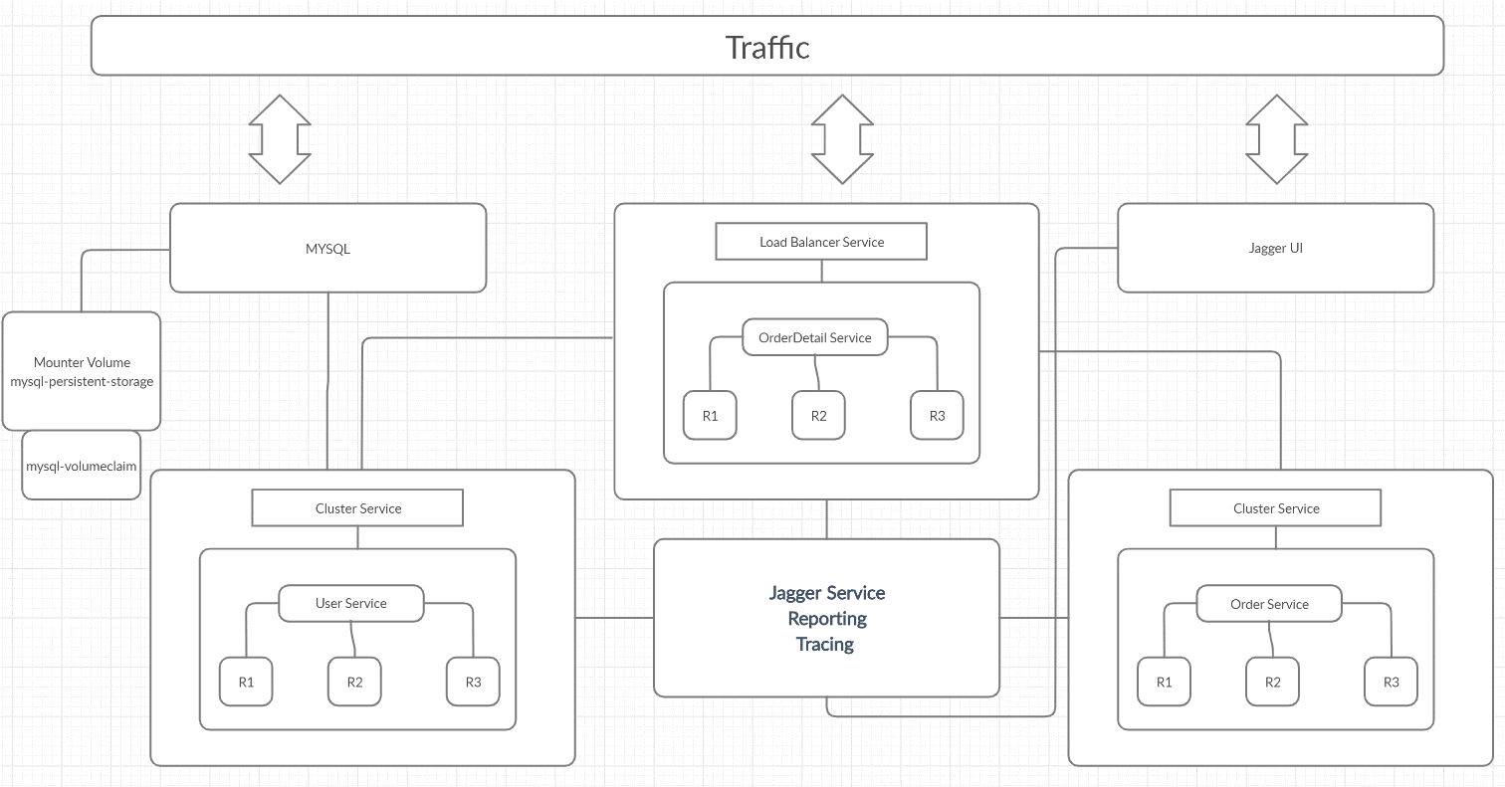

* + Setting:
    1. Secret : The password is encoded into base64 string and provided AS “cGFzc3dvcmQ=” which decodes to string “password”
    2. The environment variables are provided through config maps
    3. Storage: The MYSQL is backed with mounted volume that persists the data via mounted volume “mysql-volumeclaim” at path “/var/lib/mysql” .
  + Please find IP config as following

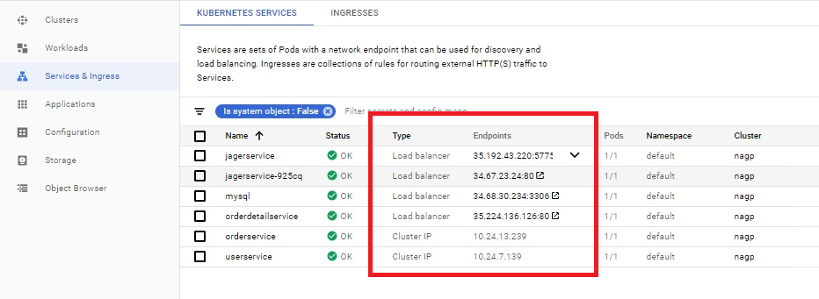

* + Basic config :Each have been deployed in “nagpKunal” cluster with 3 replica set .
  + {Locally they can ne ran with start.bat docker-compose}
* Three services have been created with following service type:
  + User
    - Type : Cluster Service This service can only be accessed internally.
    - IP :10.24.7.139
    - Endpoint :/user/1
  + Order
    - Type : Cluster Service This service can only be accessed internally.
    - IP :10.24.13.239
    - Endpoint :/order/1
  + OrderDetails
    - Type: Load Balancer: It has been exposed to external IP and when accessed it fetch detail from order and user service merge them and provide with result.
    - IP :35.224.136.126
    - Endpoint :/orderdetail/1

The OrderDetails Service is Load balancer type exposed externally that fetch and aggregates the result from User and orders service

User and Order service are Cluster Ip type and exposed internally to cluster

# Jagger:

It provides tracing ,reporting for the above services .

When OrderDetail is called it shows order and user service that are being called internally.

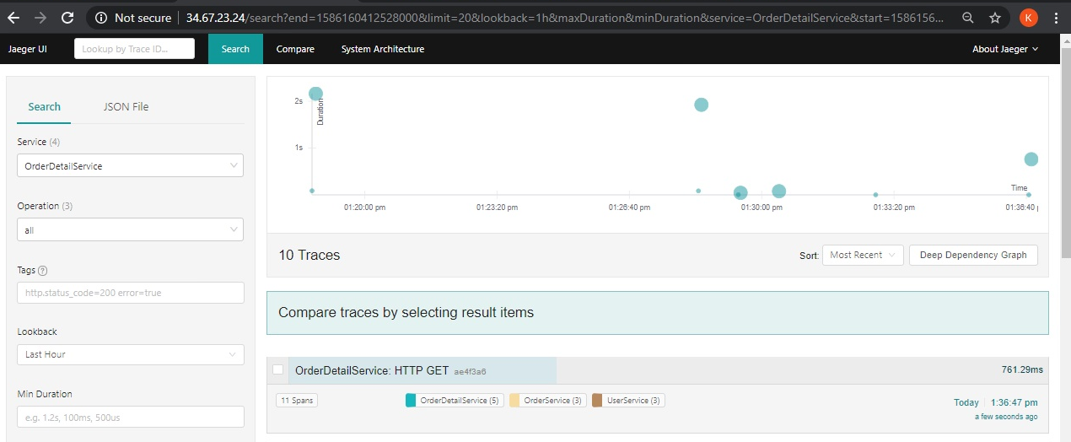

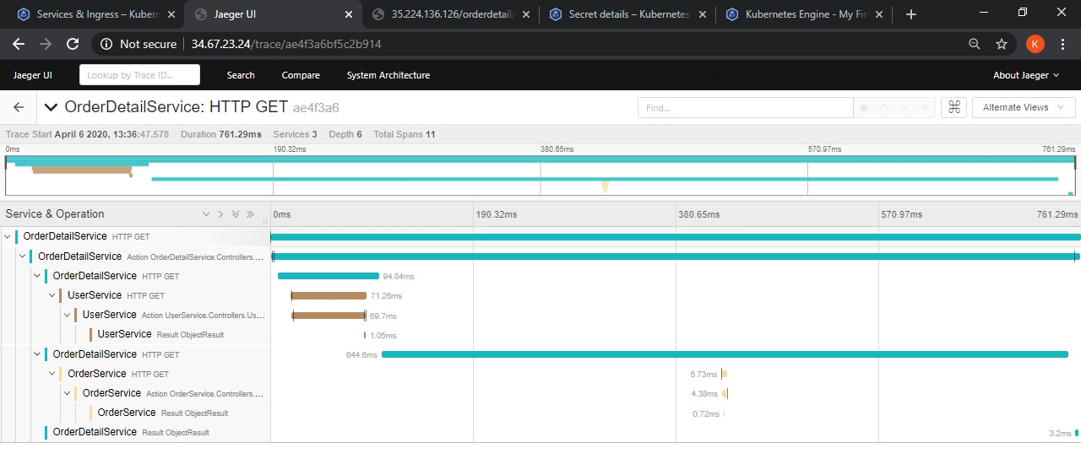JAGGER UI: <http://24.67.23.24>

Other Ports

- 5775:5775/udp

- 6831:6831/udp

- 6832:6832/udp **EXPOSED TO APPLICATIONS FOR TRACING

- 5778:5778

- 16686:16686 **FOR Jagger UI

- 14268:14268

- 9411:9411

# Database

1. MySQL is used as database.
2. Userservices fetch data from POCUser table inside sys database.
3. It is backed by mounted volume provided by PVC.
4. The password is stored and provided by secret created with key password and value

“cGFzc3dvcmQ=” which decodes to string “password”

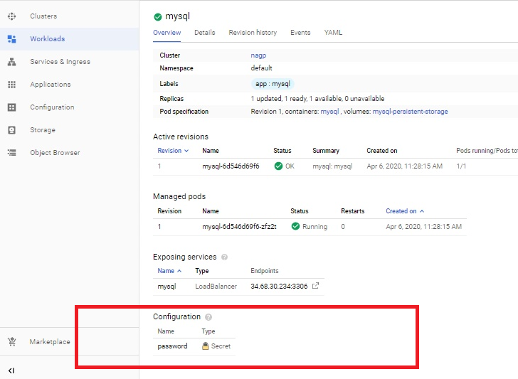

# Storage:

